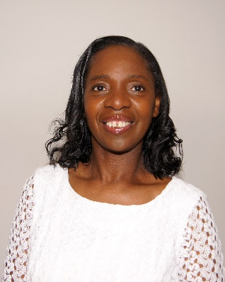Dawn Benjamin, NLDNUK Director
The founder of The Pilgrim Sacred Dancers based in the United Kingdom. Formed in 2006 after she witnessed the awesome power of Liturgical Dance as a praise and worship tool at a conference in Washington DC. She has been a member of the National Liturgical Dance Network since 2008. NLDNUK was formed in the UK the same year.
At the time there was limited information on Liturgical dance readily available in the UK. The Lord provided the opportunity for Dawn and the Pilgrim Sacred Dancers to travel extensively, attending International Dance Conferences which provided much needed training. The UK give honour to Rev Eyesha Marable NLDN Founder who regularly visits England with a team to assist in conferences to share their wealth of experiences with the United Kingdom family.
Under the umbrella of NLDNUK the Lord has established several teams, in various church denominations, to serve others by supporting and connecting worshippers all around the UK in order to restore dance as an integral part of worship to honour His Holy Name.
Dawn shared that this has been an extraordinary journey and acknowledges how the Lord had provided many mentors, as well as Rev. Eyesha Marable, Amanda Standard of Divine Dance Institute, Minister Sentheia McLeod of Cathedral Dance Ministry and Marilu Susanna from Curacao. She also received teaching and guidance from Rev. Stephanie Butler-Adams, Dr Pamela Hardy, and many others that have all contributed to establishing a Liturgical Dance Ministry that not only promotes praise and worship through dance but also unites those that minister in dance across denominational barriers.
Dawn has completed several online courses such as Back to Basics facilitated by NLDN. Graduated from PUSH 1 and 2 courses (a course initiated by Rev. Eyesha designed for UK participants) in 2017. She has completed ‘Eagles International Training Institute’ Dance 1 course in 2018. Dawn is one of the creators and Lead facilitators for PUSH 3 programme launched in 2020.

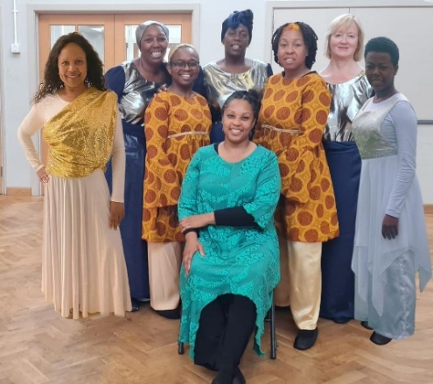Vessel of Honour - Host
2 Timothy 2: 20-21
Vessel of Honour UK, established in 2014, is a part of The National Liturgical Dance Ministry, consisting of members from different denominations in the London region and led by Sandra Julian, NLDNUK Assistant Director.
Sandra was called by God to start a liturgical dance ministry with those who felt led to dance for the Lord. VOH’s goals and purpose is to reach out to the saved and unsaved through dance, to heal, to prophesy, to set the bound free, through movement, resulting in a deeper relationship with Jesus Christ.
VOH’s current members are: Zinnette Andall, Abigail Gordon, Chantal Jones-Butt, Sandra Julian, Mitzie Livingston, Catherine Masterson, Melonie Smith, Cheryl Tate and Heva Watson. As a team, VOH has choreographed and ministered dances for various events including, Weddings, Funerals, Birthday celebrations, Conferences, Outreach activities in the community, and have had many opportunities to collaborate with choirs and bands to share the gospel message.
All members of VOH have completed PUSH (Praise until something happens) 1, 2, 3, programme, which we feel have given us the confidence as dance ministers to go forth, resulting in the birth of other dance ministries in London and Antigua. Our desire is to continue to assist in developing and equipping further dance ministries for the future generation.
We give God all the Glory and Honour and thank Him for using us in the way He has over the years. VOH feels blessed to be the Host of the NLDNUK Conference of 2023 and looks forward to welcoming facilitators and delegates locally and from other parts of the world.

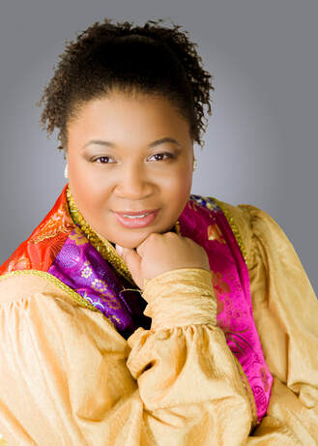
Monica Reagor – NLDN Global Director
One of the co-founders and artistic directors of Sisters of Worship International Worship Arts Ministry, an Apostolic/Prophetic ministry with the vision of releasing healing, deliverance, and evangelism through the Art of Dance. She previously served as the Director of Worship Arts at the Life Church, Baton Rouge, LA, and is currently, a member of All Nations Worship Assembly New York.
Since her call to the Ministry of Dance over the last 15 years, she has been privileged to minister with many anointed recording artists such as Israel Houghton, MaryMary, James Fortune, Vickie Yohe, Micah Stampley, and many more. She also ministered on BET's Bobby Jones Gospel with Kingdom Seekers Worship Art Ministry, accompanying gospel jazz artist - Ben Tankard.
Her dance credits include ministering with Kingdom Seekers Worship Arts Dance Company (KSWAM), Beauty from Ashes Theatre & Dance Company, Full Gospel Baptist Church Fellowship International Dance & Mime Troupe (IDMT), and Harmonious Voice for Christ Praise Dance Company (HVCPDC). Also, Sisters of Worship was nominated as the Praise Dance Ministry of the Year at the New Orleans Gospel Awards.
Monica now serves as the President & Executive Director for National Liturgical Dance Network, which Rev. Eyesha Marable founded. Monica Reagor travels the nation teaching, preaching, and ministering through the gift of dance. She also mentors and develops individual ministers and dance ministries nationwide to serve Christ’s body excellently.
She desires that worshipers from every denomination, every nationality, and every walk of life will come together in one place to worship the Father in Spirit and Truth.

Minister Hope Radiance Boyd
The founder and executive director of ‘Yahweh in Motion Dance Company of the Arts’, based in Tampa, Florida.
This ministries heartbeat is to cultivate dancers and creative gifts unto the Kingdom of God. Providing a platform for creatives to find deliverance, restoration, hope, salvation in Christ through the arts. We are ‘Isaiah 61 in Motion’.
Hope’s desire is to continue to evangelise throughout the communities and nations using the power of the arts to impact humanity. Ultimately win souls for the Kingdom of God.
Hope is also NLDN Global Director of Youth Engagement and Development and within this role she has worked directly with a number of young people in the UK teaching Liturgical Fusion dance technique.

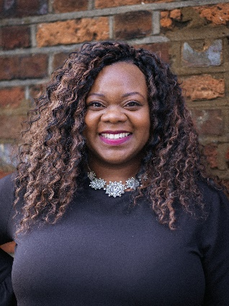Francesca McDowall

Francesca McDowall is a Liturgical Dance Minister with Released to Worship, based in the UK. She has been ministering the word through movement for over 10 years and in particular through banners and flags.

Francesca has ministered in conferences, weddings, funerals and at outreach events. She is committed to encouraging and teaching other dance ministers to develop their gifts, and is a member of the NLDN.

Francesca is passionate about supporting individuals to heal, be made whole and pursue God’s purpose for their life and founded the ReStart Therapeutic Coaching Programme to facilitate this.

In her professional life Francesca runs Elevate Coaching & Consultancy Ltd and as an experienced Managing Director, Public Speaker, Leadership Coach and Award-Winning Mentor, works with individuals and groups on their personal and professional goals.

She is also a published author of several books. Francesca served as a leader in her local church in the Midlands for several years before relocating to Buckinghamshire in 2021.

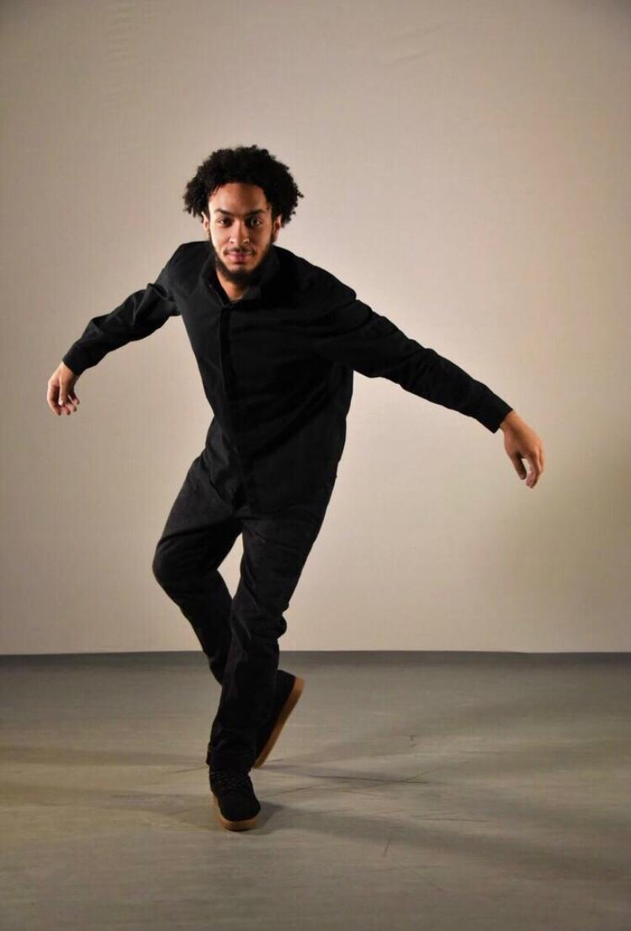

Bro. Judah Marable graduated from Montclair State University in 2022. He began teaching in the UK in 2009 at the age of 8 at their first conference where he taught a dance, he had choregraphed by Donnie McClurkin entitled ‘Again’.

He began his classical ballet/modern training at the age of 16 and was asked to lead a dance ministry at Israel Memorial AME church that same year. This ministry has grown to what is now known as R.O.A.R (Reclaiming Our Adolescent Righteousness) Dance Ministry. Judah has also birthed “The Reason Why” Liturgical Dance Ministry out of his home church Elmwood United Presbyterian Church where his pastor is Maria Crompton.

He has sat under the leadership of ministers such as Dr. Kathleen and Curtis Turner, Freddie Moore, Pastor Eyesha Marable, and Brian Hawthorne. He has also had the chance to work with various choreographers as a freelance artist. Judah has premiered in works with Dramatic Truth Ballet Theatre, OcompoWang Project, We Move in Colour, Zion Dance Project, etc.

Since graduating from Montclair, Judah has travelled to various parts of America and Europe teaching the gospel through liturgical dance including MAS Que Vencedores and El Olam respectively teaching classes to dancers of all ages and abilities.

Judah’s desire has been to be a professional Liturgical Dancer, not only setting choreography, but leading the overflow of the Holy Spirit. Being an acceptable vessel for the Lord to do His work in. Judah hopes to share his ministry with dance ministers from around the world. Judah continues to be a regular facilitator at the United Kingdom biannual conferences. No matter how far away from home he is, he understands the Omni of God and adheres to that. To God be all the Glory.

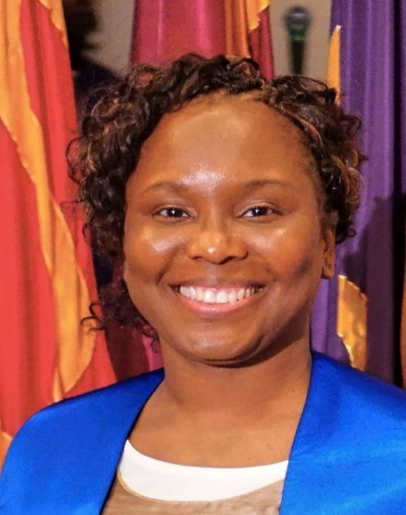
Minister Marita Young
Minister Marita Young is an ordained minister who serves as the team leader for the ‘Moving Word Dance Ministry’ at Ruach City Church. She also serves in the ministerial team and the Spiritual Mediation department.
In 2015 she became a Licensed Dance Minister through the Eagles International Training Institute which fueled her passion to see creatives discover their true purpose.
She is the founder of ‘Ministers of Movement Mandate’ and ‘United for the Kingdom’, which focuses on bringing creatives together for kingdom exploits. She equips ministers of movement and worshippers to impact the world for Christ through educational, training, and mentoring programs. Her workshops range from prophetic dance, dances of intercession, technique classes in Jazz, Horton and Graham and Kingdom choreography.
Minister Marita runs a successful youth dance company and for the last 12 years has been an examiner for BTEC Performing Arts, GCSE, and A Level Dance. She is also one of NLDNUK PUSH 3 Exam advisor and Assessor.
Minister Marita is also a qualified fitness and Pilates instructor and has recently qualified as a Psalms and Stretches Instructor.

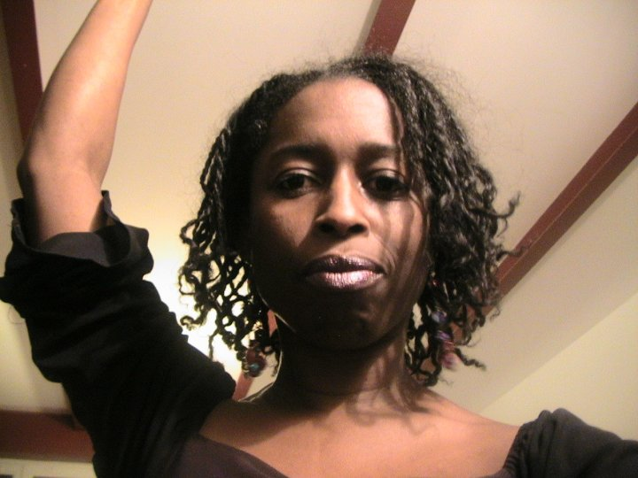
Alison Ray
Alison Ray MA was trained at the Laban Center of Movement and Dance now Trinity Laban Conservatoire of Music and Dance. She has worked professionally for various choreographers from Europe, Africa, and the UK.
She has also worked for Peter Badejo (OBE), French African Choreographers Koffi Koko and George Momboye. While in Europe she worked for choreographer Maurice Bejart, as part of Beethoven’s 5th; Craig Revel Horwood for Eurodisney’ “Legend of the Lion King” first cast.
Alison completed her MA of Choreography at Trinity Laban Conservatoire of Music and Dance, and she works professionally as a Choreographer and author.
Currently, she choreographed the production the Unknown Soldier a interdisciplinary work based on the Black British War veterans. Next performance Army at the Fringe Edinburgh.
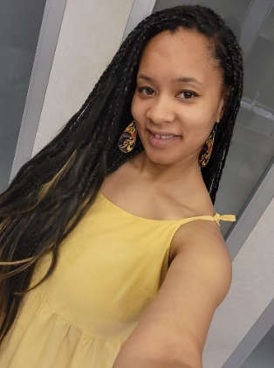
Tracey Letts
Freelance Mixed Media Artist
Tracey holds a BA (Hons), PGCE qualifications and supports academic success/wellbeing support in further education. With over 5 years of working in post compulsory education, Tracey has developed her mixed media art collections supporting liturgical dance, craft, fine arts, and mental health.
First joining the network in 2011 after a prophetic word released naming the ministry, HE - ART the Fathers heart and showcasing her artwork in New York with Rev Eyesha in 2012. Tracey has continued to develop her personal artistry and skill capturing dancers, landscapes, and prophetic imagery whilst over the years supporting the NLDN offering flag making courses and live art during services. 2016 saw the development of paint and sip sessions with the initial support of the NLDN offering creative workshops with a twist and teaming up with independent designers and makers to develop their creative calling.
She has since showcased and developed creative spaces called the 'creative table' during worship conferences within a network of churches in the midlands for congregants to develop their creative artistry during services and continues to facilitate social art classes for her local community, and has exhibited pop up collections within local libraries and is currently a board member supporting creative community enterprises in disenfranchised communities in the West midlands.

